Training Certification for Centuro Pump
Electrical Information
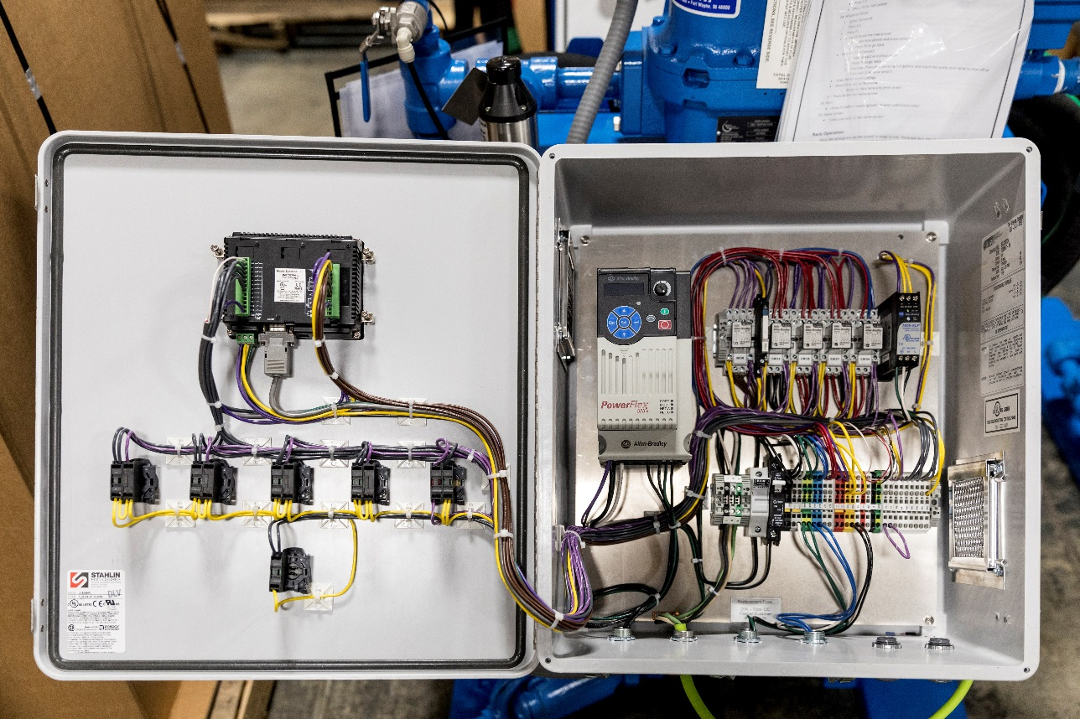
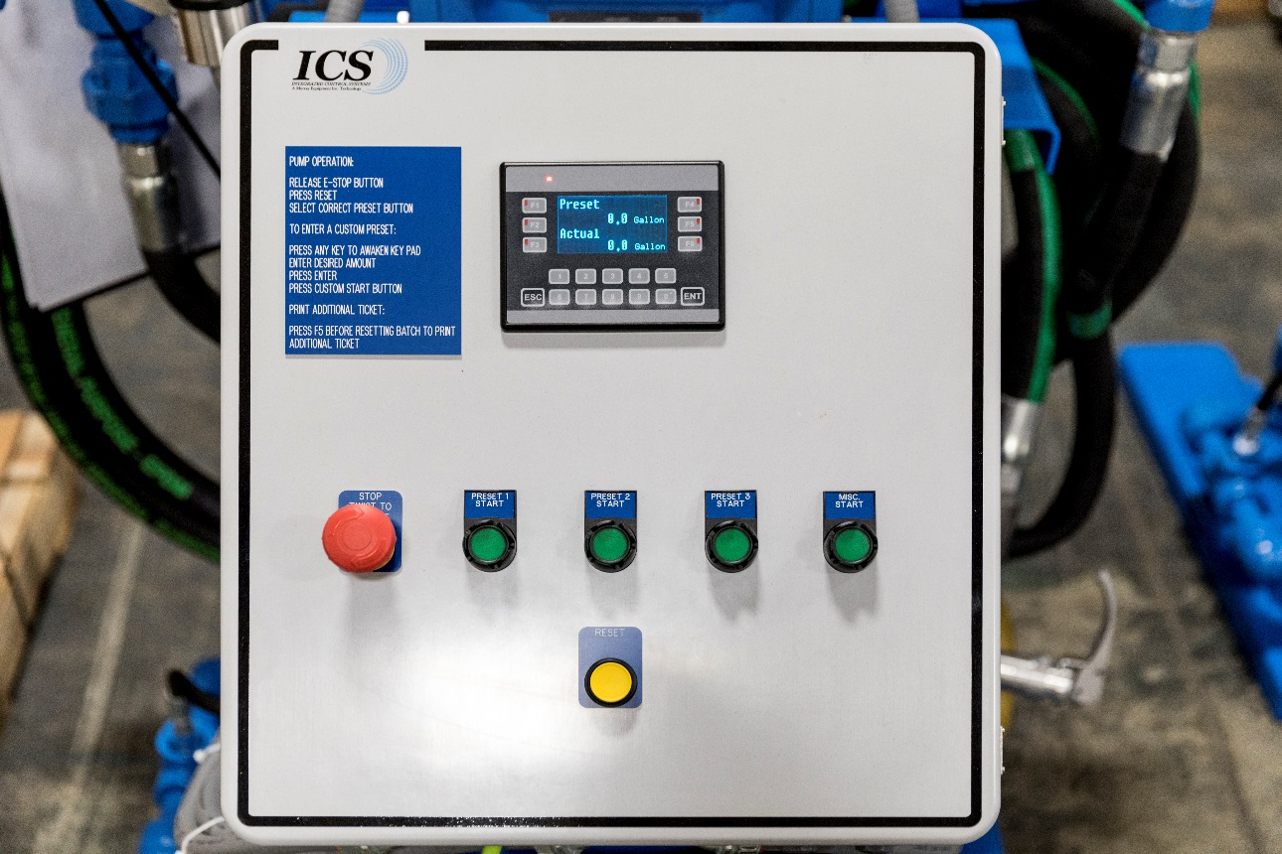
Introduction
When looking at the wiring and components in the Centuro Pump stand’s electrical box there are some wiring and a few components to be aware of. Notice when the incoming power is coming into the box it is split, one end goes to the 3-amp circuit breaker, for the control wiring, and the other goes to the 20 amp. fuse for the VFD (See Figure 1 & 2 Below). The panel is designed this way since the VFD and control wiring both need different levels of protection. The VFD Fuse and the VFD itself are both important parts of this electrical box since they control the pump for this pump stand.
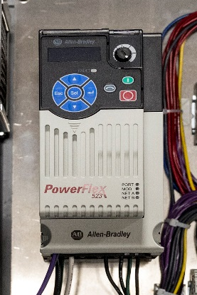
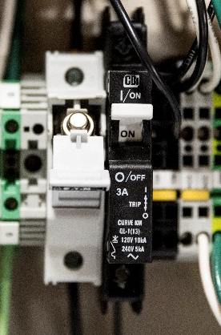

Figure 2

Figure 1

Along with the VFD, the DC Power Supply is also an important component to keep in mind when working with this electrical box. The DC Power supply is important since it is the sole provider of DC power in this box (See figure 3). One of the most important components, the Maples HMI, will only work with DC Power. The Maples HMI is the “Brains” and the GUI of the Electrical box (See figure 4 & 5). It controls everything in the electrical box from the VFD to counting the pulses from the meter, so it knows when to shut the valve and turn off the pump.
Maples HMI

Maples HMI

DC Power Supply

VFD
20 Amp. Fuse Holder
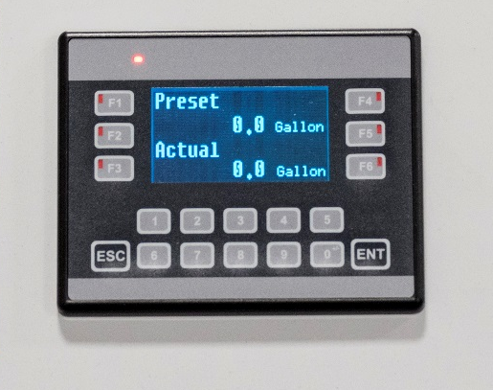
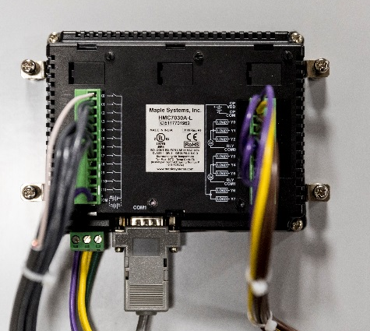
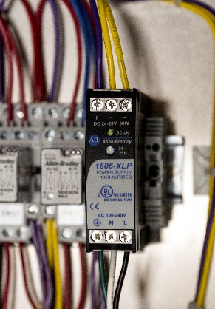
Figure 5 (Back)

Figure 4 (Front)

Figure 3

Maples HMI Hardware & Software Troubleshooting
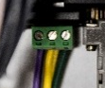
What to look for if HMI is failing
- If Screen is not powering up
  - Check incoming power on the screen for 24V DC. (Figure 6)
    - If the screen has 24VDC then the screen is bad.
Figure 6

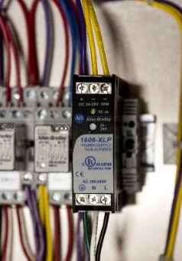
  - Check DC Voltage coming out of the DC Power supply. (Figure 7 Red Circle)
    - If there is no DC Power coming out of the power supply check the incoming AC Power. (Figure 7 Blue Circle)

    - If there is 120 VAC Supply Power the DC Power Supply is bad
  - Check terminal blocks and make sure they are seated correctly.
What to look for if HMI Program is failing, i.e. Meter counts aren’t showing up
- Check all settings, i.e. Preact, No-Flow Timer, Max preset, etc.
Figure 7

- Check positive DC Power wire on IP COM. (Figure 8)
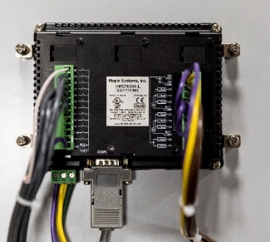
  - If this isn’t suppling +24 VDC then we won’t see any inputs from the start buttons or the pulses from the meter.
- If all wiring and settings are good in the program, the screen will need replaced and sent to Murray equipment for further inspection.

Figure 8

Replacing the Maples HMI
If the Maples Screen isn’t powering on or isn’t working correctly after all settings have been checked, it will need changed out. To change out a maples screen first power down the panel. To shut power off flip the breaker in the bottom of the panel (See Figure 9). Once there is no power remove all the terminal blocks from the back of the screen along with the DB9 connector in the bottom of the screen (See Red Circles in Figure 10). Once everything is unplugged from the screen use a Flat head screwdriver to remove the four mounting screws (See Blue Circles in Figure 10). When the screws are out, remove the screen through the front of the enclosure. Now that the old screen is removed insert a new screen into the hole and tighten down the mounting screws. Once it is secure insert all the terminal blocks and the DB9 connector. The maples screen has now been successfully switched out and is ready to be powered up.

Figure 10

Figure 9

Power Flex 523 VFD Troubleshooting
- What to look for if VFD is failing
  - If VFD is not powering up.
    - Check supply power (120VAC) on terminals L and N. (See Figure 11)
    - Check Fuse on the supply power.
    - Check Power wires directly on VFD for 120VAC. (See Figure 12)
    - If these three tests pass, then the VFD needs replaced.
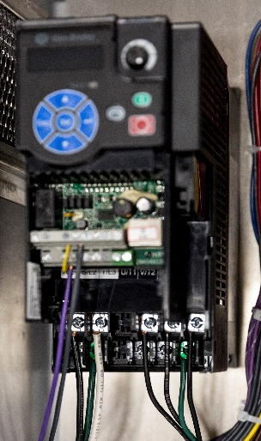
1

2

Figure 12

Figure 11

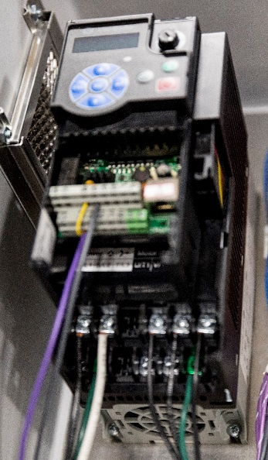
Replacing the Power Flex 523
If the VFD isn’t powering up and needs replaced the first thing that needs done is power needs to be turned off to the panel. To Power off the VFD unplug the box from the outlet and remove the fuse. Once power is turned off be sure to wait a minute since the VFD can hold voltage. Once the VFD is powered down remove the wires, making note where they were landed. When all the wires are removed start removing the mounting screws, there are two on top and two on bottom. (See Figure 13). With all the screws removed just pull the VFD off the backplate and put the new one in its place. Tighten the mounting screws back down and re-land all the wires that got removed and the VFD is ready to be powered up. Once the VFD is powered up check the parameters to make sure the VFD is set up and ready to run.

Figure 13

Control Panel Parts List

3

1

2

5

4

15

14

13

12

11

6

10
0
9

8

7
Item | Part Number | Description
1 | MPL HMC7030A-L | Maples HMI & PLC
2 | ABE 800FP-MT44 | Twist to Release E-Stop
3 | ABE 800FPQ3G  MEI 800FPLG3 | 24 VDC Lighted Start Button
4 | MEI 800FPF5 | Yellow Push Button
5 | INM H0839-2 | DB9 Male Connector
6 | ABE 800FQ10 | Normally Open Contact Block
7 | ABE 1.5HP-VFD | PowerFlex 523 VFD
8 | ABE 700-HN103 | 4 Pole Relay Base
9 | REC 700HLT1U24 | 24VDC Interposing Relay
10 | ABE 700HC24Z24 | 4 Pole 24 VDC Relay
11 | ABE 1606XLP30E | 24 V 1.3 Amp DC Power Supply
12 | ABE 1492J4 | High Amp Screw Terminals
13 | BUS CHCC1DU  BUS LP-CC-20 | Fuse Holder  20 Amp Fuse
14 | MWA 1CU3 | 3 Amp Circuit Breaker
15 | ABE 1492-L3T-Y | Spring Terminal
Control Panel Parts List Cont.

