Replacing the Pulser
Replacing the pulser can be done without removing the pulser and register from the stand.

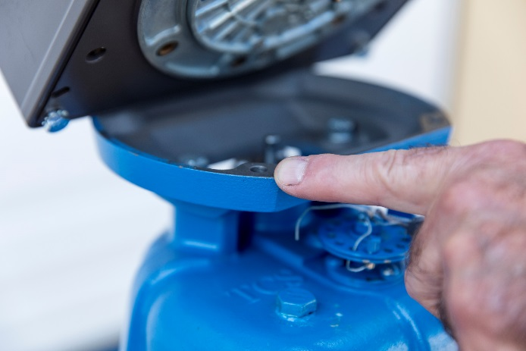
- Remove 7/16” bolts (4) that attaches the Meter to the Register.

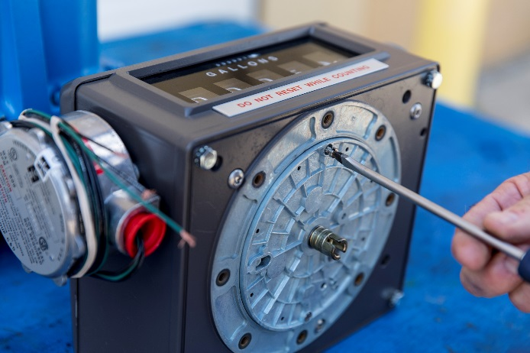
- Remove Gear plate by removing 2 flathead screws from the bottom of the register.

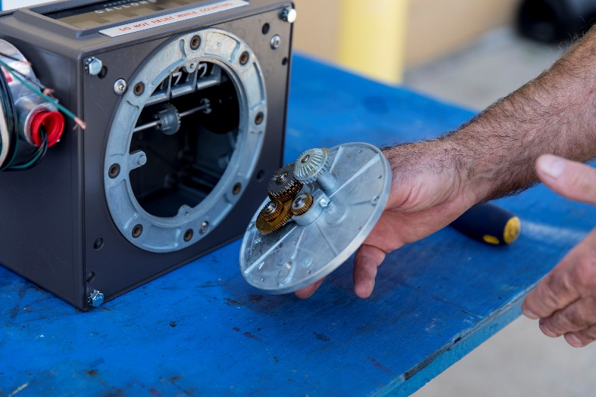
- Remove Gear Plate from the bottom of the Register.

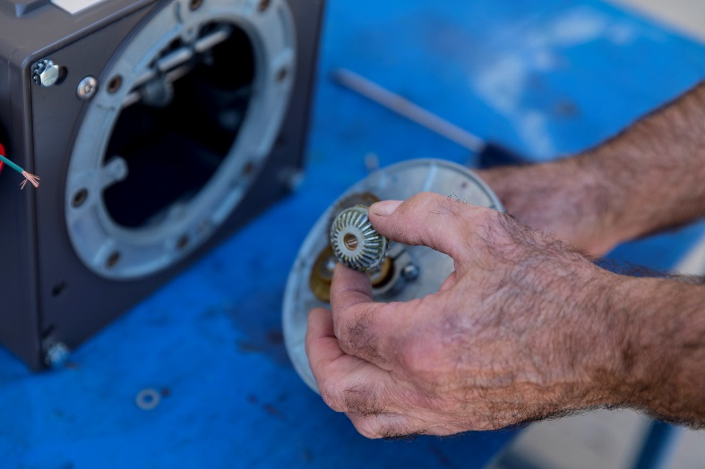
- Be careful not to drop the gear and the washer as you are removing the Gear Plate.

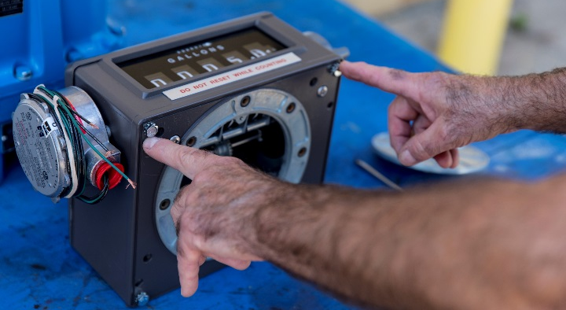
- Remove 7/16” bolts (4) that attaches the Register Lid to the top of the Register.

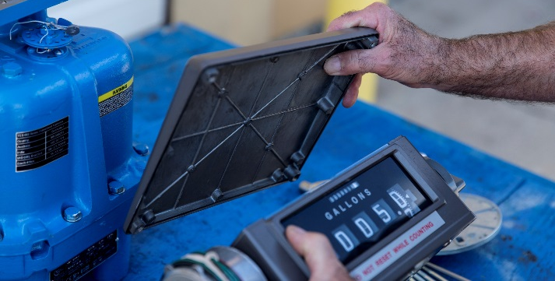
- Remove Register Lid from Register

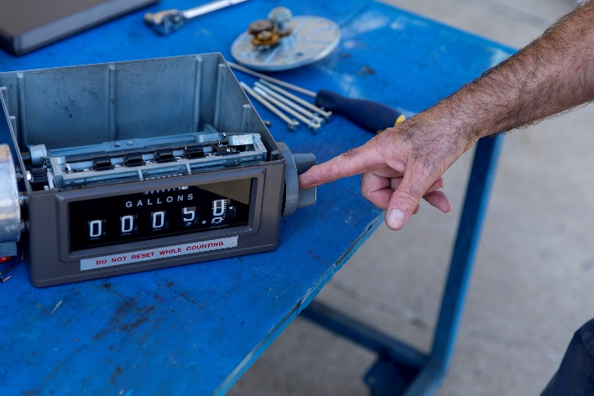
- Remove the Reset Knob by unscrewing it counterclockwise from Register.

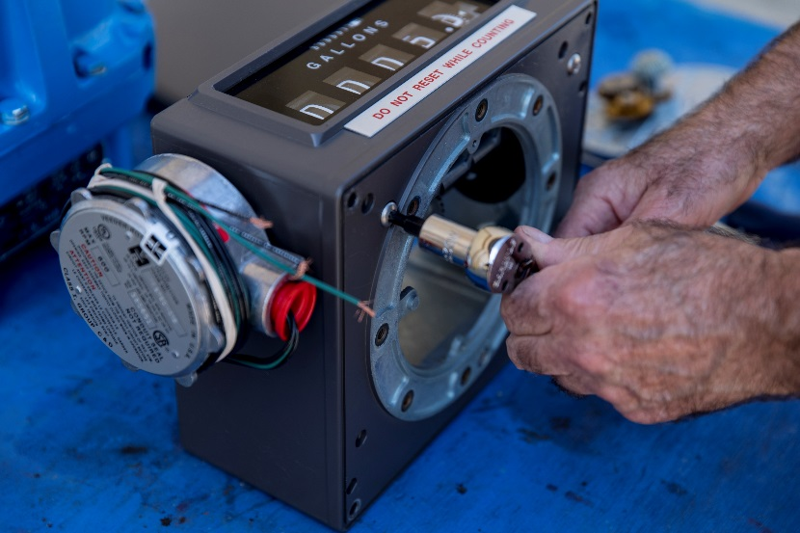
- Remove the Inner Register by removing 3 screws with #30 Torx Bit.

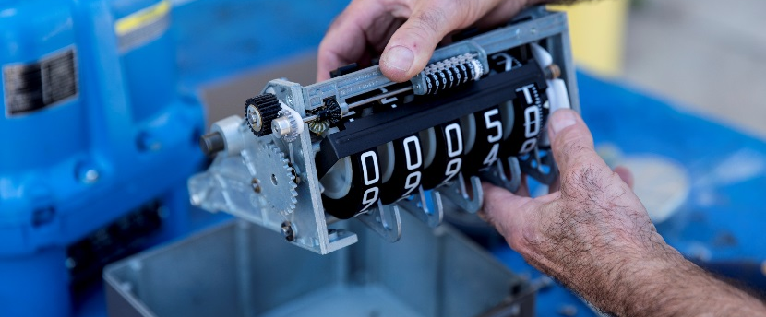
- Remove Inner Register

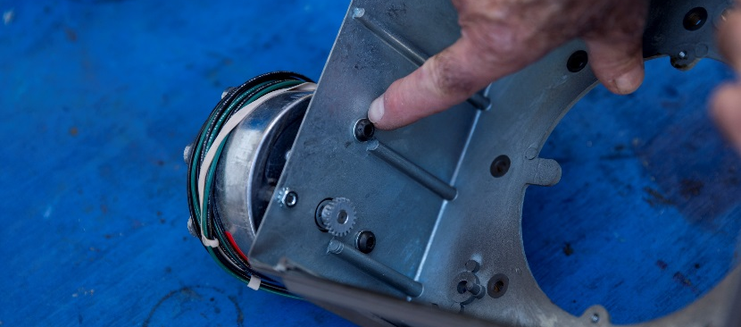
- Remove 5/32” Allen Head Bolts and one nut from side

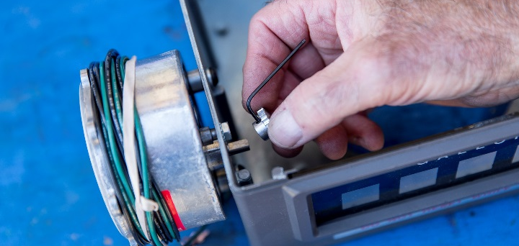
- Remove gear by loosening 1/16” set screw

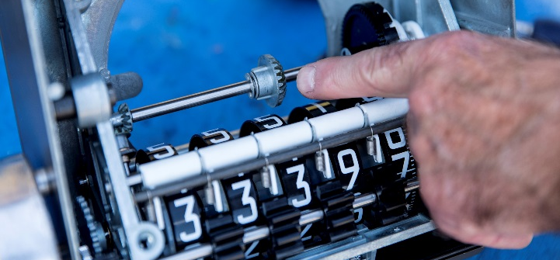
- Bevel Gear can move so when installing the Gear plate be careful to make sure it is in the center and aligned with the gears.

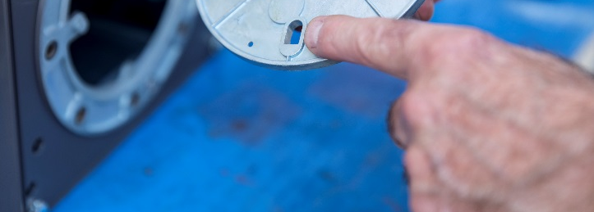
- When putting the Gear Plate back onto the Register there is a slot on the plate that aligns with the nipple on the Register.
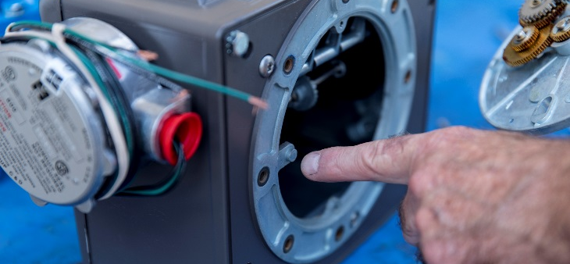

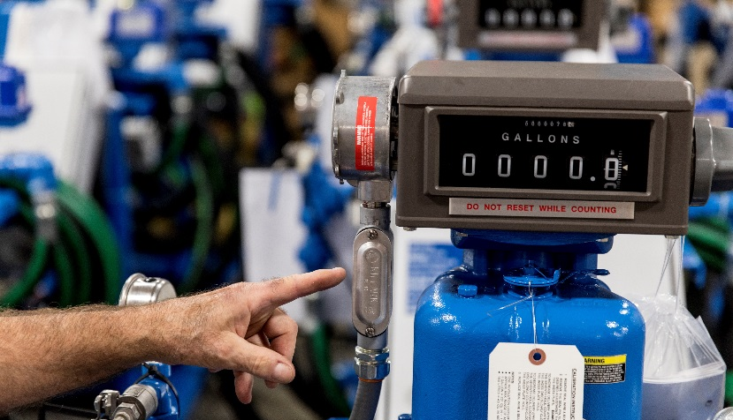
- Wire in the new pulser
